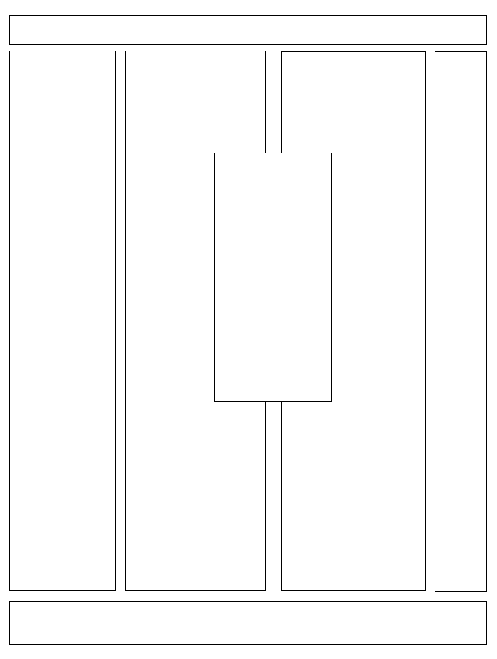

Name of Text

Who wrote, contributed to, or compiled the book?

When and where was it written?

When is it read?

What questions do you have about the book or text?

What is an example of a short text (in English) in the book?

What are the different parts of the book? How is it structured?

Draw or cut and paste a cover from the text here in English and Hebrew.